

**PRIMARY SECTION - 3 TO 5**

**Healthy Food – Notes**

**Subject – English**

**Grade- 3**

**Answer the following questions:**

1. **Give two differences between cold drinks and fresh fruit juice** :

Ans. The two differences between cold drinks and fresh fruit juices are:

i) Cold drinks give us excess sugar, while fresh fruit juices give us vitamins.

ii) Cold drinks are bad for health while fresh fruit juices are good for us.

1. **What is a balanced diet?**

Ans. A balanced diet is a diet that contains all the essential nutrients like proteins, vitamins, carbohydrates, minerals and roughage in right proportion.

**Think and Answer:**

1. **Why was Mrs Sharma not happy?**

Ans. Mrs Sharma did not want her children to eat junk food so she was not happy.

1. **Do you think the children liked the lunch Mr Sharma and Mrs Sharma planned for them? Which sentence tells you this?**

Ans. The sentence- “Raghav , Kush and Sarthak smiled happily as they entered a restaurant.”_tells that the children liked the idea of lunch Mr and Mrs Sharma planned for them.

**Reference to Context:**

Read this sentence and answer the questions that follow.

**“They are rich in proteins and some vitamins....”**

1. **Who said these words and to whom?**

Ans. Mrs Sharma said these words to Sarthak.

1. **What does ‘they’ refer to?**

Ans. ’They’ refers to milk, cheese , eggs and meat.

1. **When did the speaker say this?**

Ans. Mrs Sharma said these words when Sarthak enquired about a balanced diet.

1. **Do you eat foods that are rich in proteins and vitamins? Name any two food items**.

Ans. Yes, I eat food that is rich in proteins like cereals and paneer.

**HOTS Question:**

Q1) **Is eating too much ice cream and French fries good for health? Pick a line from the story to support your answer.**

Ans. No, eating too much ice cream and French fries is not good for health. The line-“If you eat too much ice cream and French fries, your body will get excess of sugar and fat.”-tells us that they are harmful for our health.

**Picture Composition**

Look at the picture and answer the questions given below:

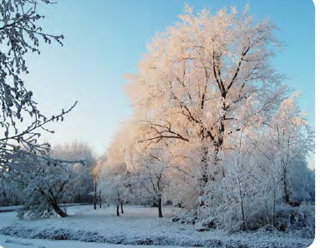

1. What season is it?

A. winter

B. summer

2. When is it?

A. noon

B. midnight

C. morning or evening

3. Why do the trees look that way?

A. The trees are dying.

B. A storm covered them with ice and snow.

C. They are blooming

4. How would your footsteps sound if you were to walk on the ground?

A. squish

B. slurp

C. crunch

5. What might live nearby?

A wild moose

B. a wild giraffe

C. a wild alligator

**Complete the paragraph by filling the blanks with the words given in the box.**

**A Healthy Lifestyle**

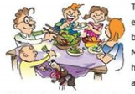

**routine homemade excited healthy**

**exhausted week difficult**

The Thompson family had been trying to eat______________ meals for a very long time, but found it__________ to keep it up .Mr and Mrs Thompson worked long hours at hospital, and felt ____________when they arrived home. For months Mrs Thomson had been ordering food during the_________. Thomson’s family knew that it was a bad____________. So they decided to eat ___________ food and felt very __________about the change in their life.

**Write a story to go along with the picture.**

The illustration shows a father and son on a fishing trip. The father's got a tiny fish and his son has a giant fish. Give a title to your story.